Министерство образования Республики Беларусь

Учреждение образования

БЕЛОРУССКИЙ ГОСУДАРСТВЕННЫЙ УНИВЕРСИТЕТ

ИНФОРМАТИКИ И РАДИОЭЛЕКТРОНИКИ

Кафедра информатики

Лабораторная работа № 13

по дисциплине «Методы численного анализа»

по теме «Метод сеток решения одномерного нестационарного уравнения теплопроводности»

Выполнил:

студент гр. 853502

Шаплыко Н.А.

Проверил:

Анисимов В.Я.

Минск, 2020

**Цель работы**

1. Изучить метод разностных аппроксимаций для уравнения теплопроводности;

2. Составить алгоритмы решения уравнения теплопроводности методом сеток, применимыми для организации вычислений на ПЭВМ;

3. Составить программы решения уравнения теплопроводности по разработанным алгоритмам;

4. Выполнить тестовые примеры и проверить правильность работы программ;

5. Получить численное решение заданного уравнения теплопроводности.

**Краткие теоретические сведения**

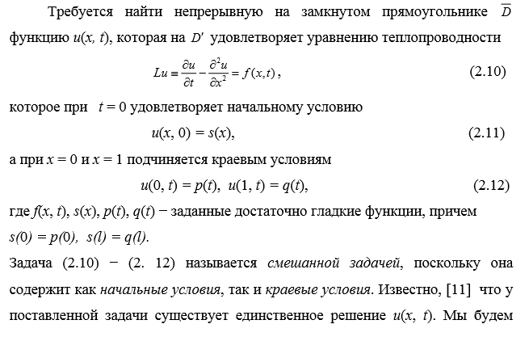 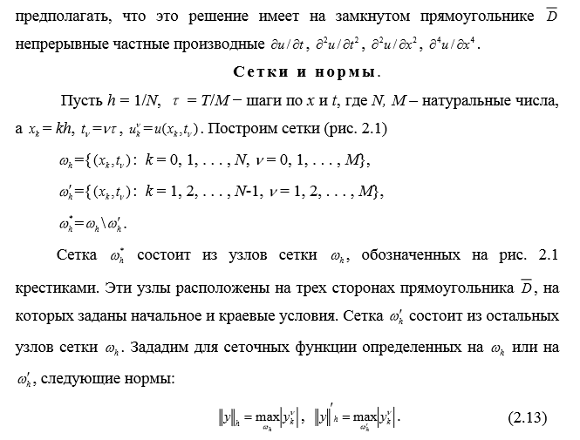 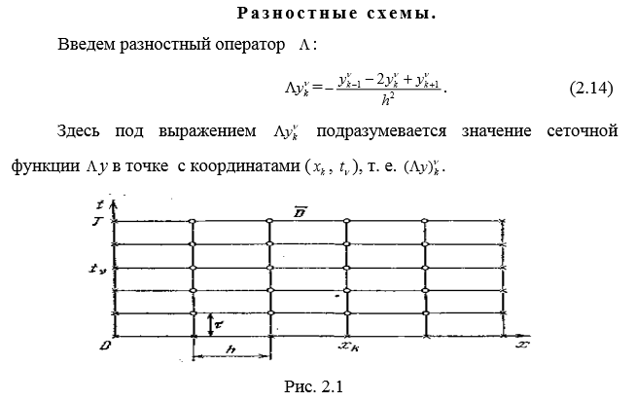 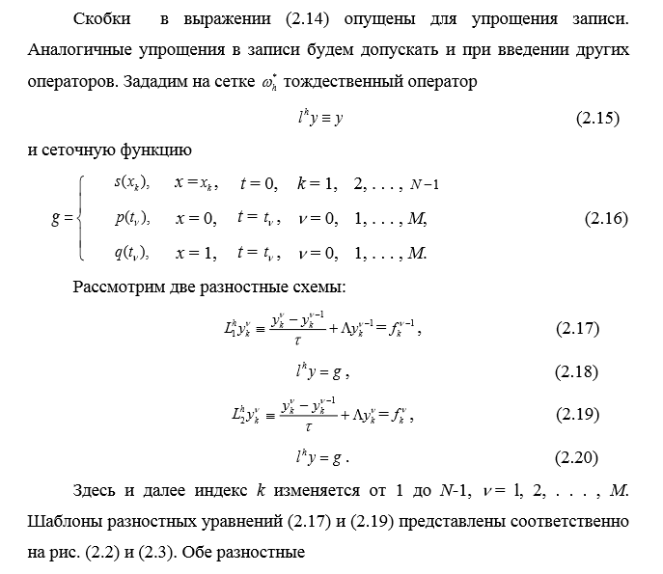 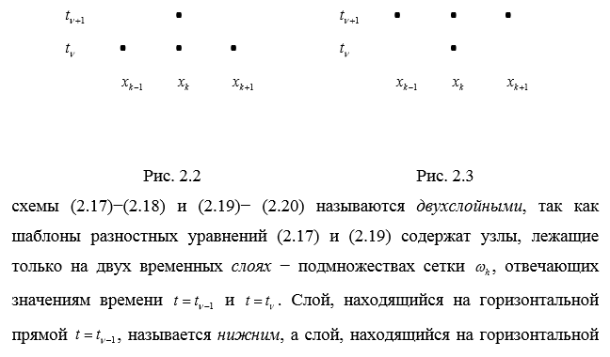 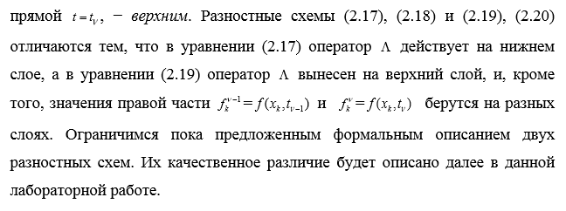

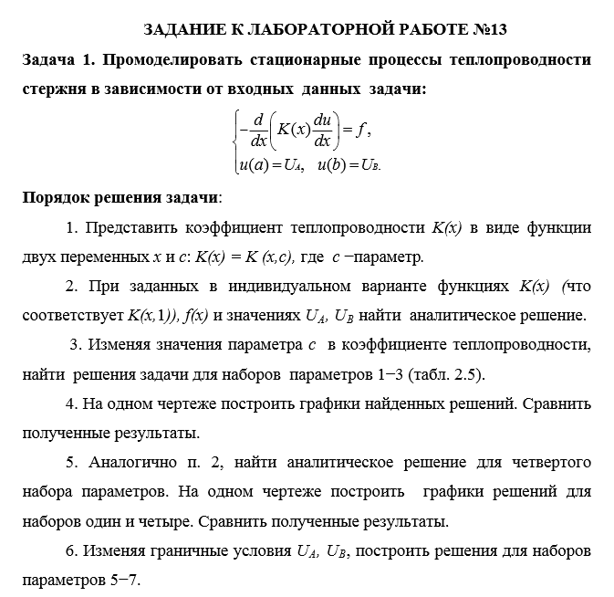

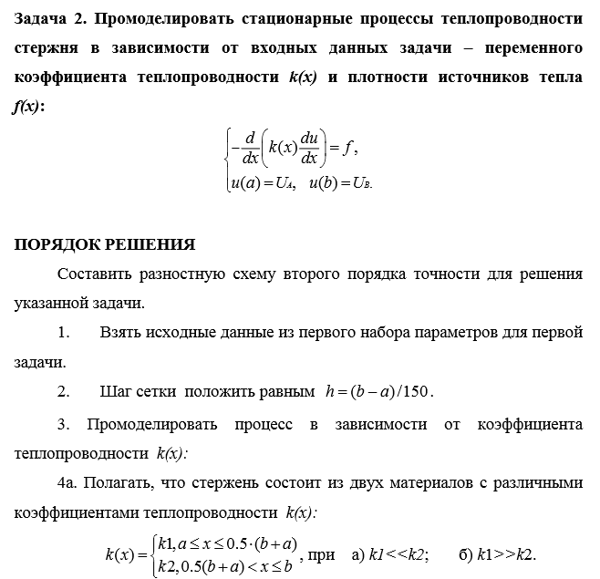 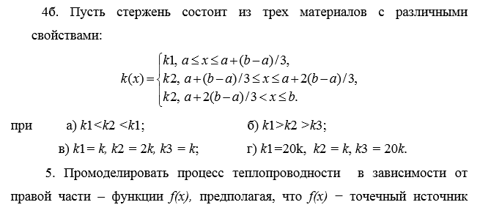 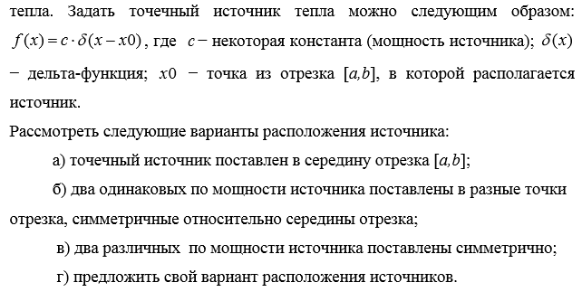

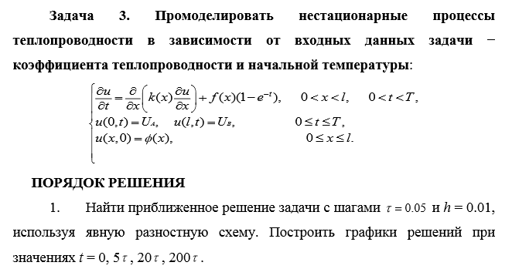 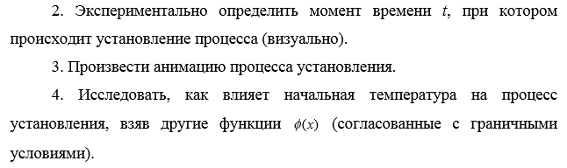 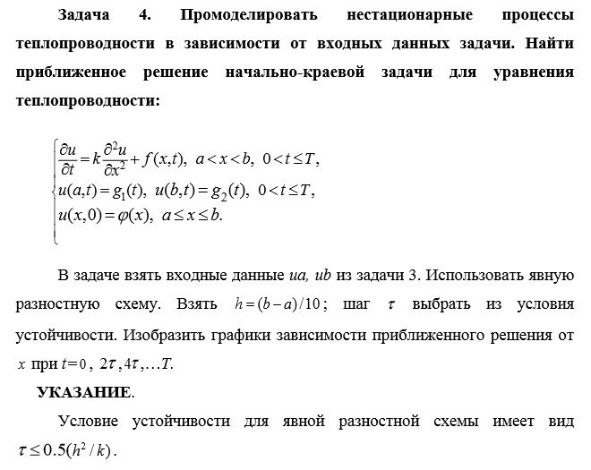

**Результаты**

Задача 1.

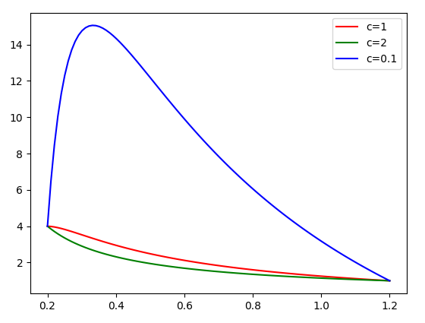

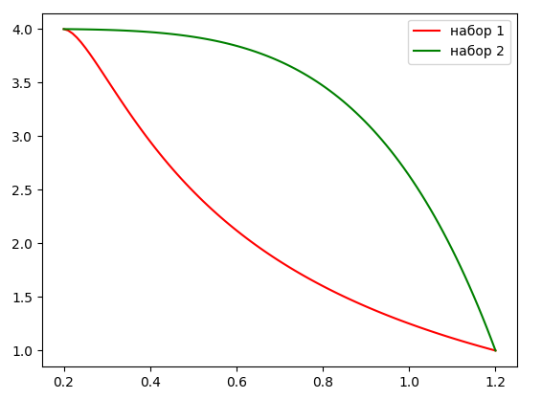

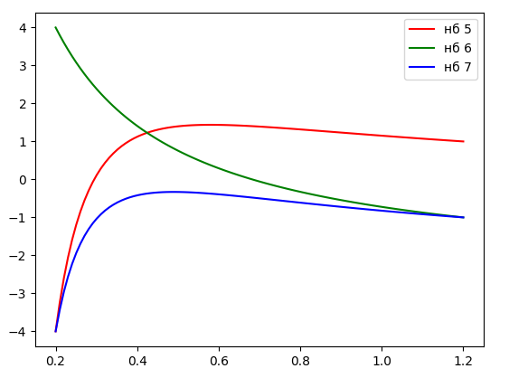

Задача 2.

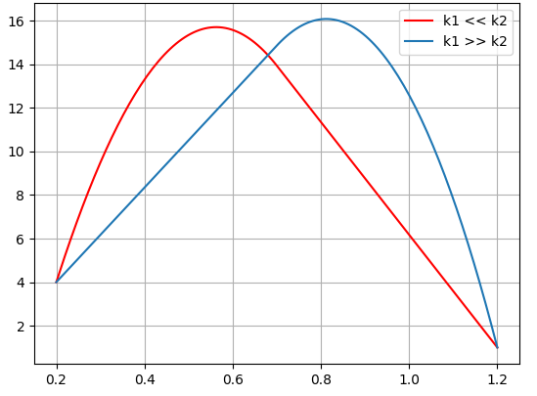

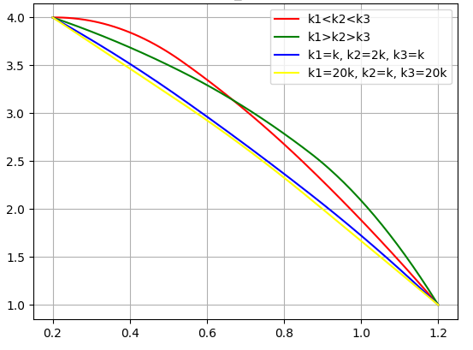

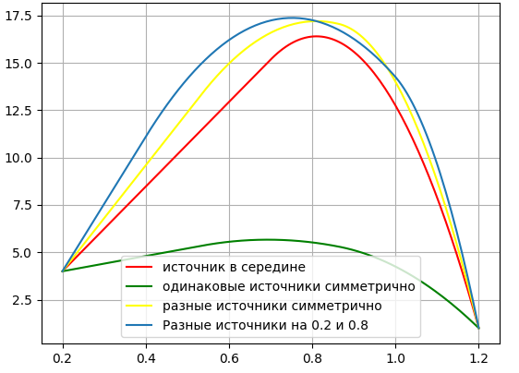

Задача 3.

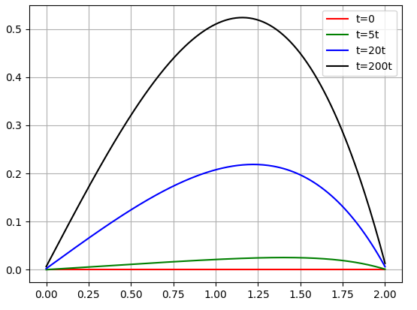

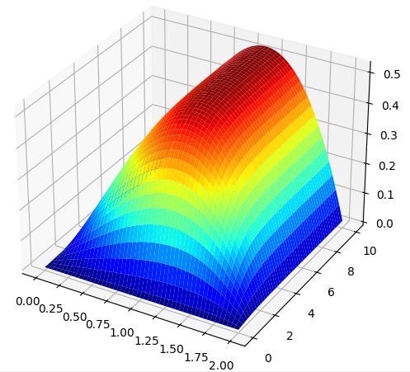

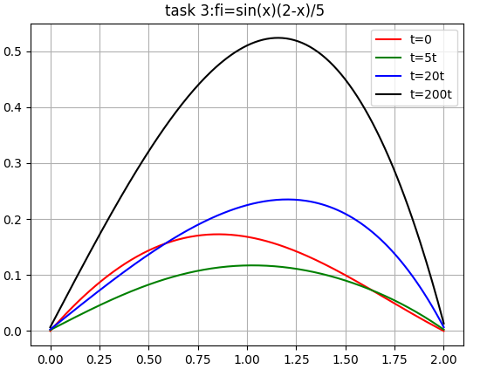

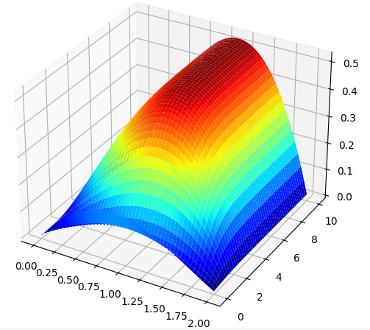

Задача 4.

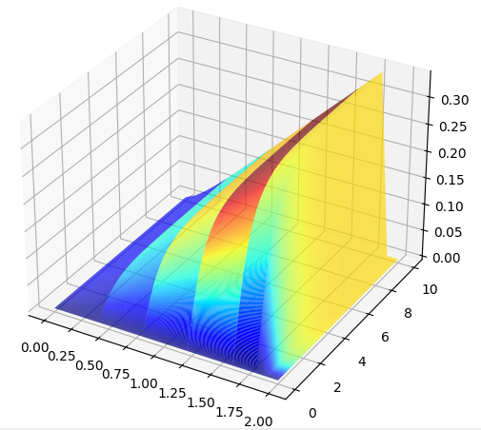

**Выводы**

В ходе выполнения лабораторной работы:

* Изучил метод разностных аппроксимаций для уравнения теплопроводности
* Составил алгоритмы решения уравнения теплопроводности методом сеток, применимыми для организации вычислений на ПЭВМ
* Составил программы решения уравнения теплопроводностипо разработанным алгоритмам
* Выполнил тестовые примеры и проверил правильность работы программ
* Получил численное решение заданного уравнения теплопроводности

**Задания**

* Первое задание было направлено на изучение функций, описывающих функцию теплопроводности.
* Вторая задача направлена на изучение поведения решения в зависимости от функции теплопроводности.
* Третья и четвертая задачи ислледуют нестационарное уравнение теплопроводности.

**Листинг кода**

Файл main.py (основной)

import sympy  
from sympy.solvers.solveset import linsolve  
from sympy.solvers import solve  
import matplotlib.pyplot as plt  
import numpy as np  
from mpl_toolkits.mplot3d import Axes3D  
from matplotlib.colors import LinearSegmentedColormap  
from matplotlib import cm  
import math  
import lab2  
  
import pylab  
from mpl_toolkits.mplot3d import Axes3D  
  
from numpy import linspace  
from collections import namedtuple  
  
POWER = 5  
POWER5 = 25  
POWER_1 = 35  
POWER_2 = 15  
POWER_3 = 10  
POWER_4 = 30  
ITER_COUNT = 150  
LINSPACE_SIZE = 100  
x = sympy.Symbol('x')  
  
a = 0.2  
b = 1.2  
u_a = 4  
u_b = 1  
my_k = 1  
  
  
def k_1(x, c):  
 return x ** 3  
  
  
def function_1(x):  
 return 1.0 + x ** (1 / 3)  
 # return x + x**(1/3)  
  
  
def build_final_equation(f, k, c, c1, c2):  
 first_iter = (-(sympy.integrate(f(x), x) + c1) / k(x, c)).expand()  
 second_iter = sympy.integrate(first_iter, x) + c2  
 return second_iter  
  
  
def func_for_partition_2(yk_m1, yk, yk_p1, h, k=1, func=None):  
 if not func:  
 func = function_1  
  
 func = -k * (yk_p1 - 2 * yk + yk_m1) / h ** 2 - func(x)  
 return func  
  
  
# this function returns final thermal conductivity function  
def solve_thermal_conductivity_equation(f, k, c, a, b, u_a, u_b):  
 c1, c2 = sympy.Symbol('c1'), sympy.Symbol('c2')  
 true_eq = build_final_equation(f, k, c, c1, c2)  
 c2_val = solve(true_eq.subs(x, b) - u_b, c2)[0]  
 true_eq = true_eq.subs(c2, c2_val)  
  
 c1_val = solve(true_eq.subs(x, a) - u_a, c1)[0]  
 true_eq = true_eq.subs(c1, c1_val)  
 print(true_eq)  
 return true_eq  
  
  
def differences_method(start_variables_count,  
 a,  
 b,  
 y_a,  
 y_b,  
 func_for_partition,  
 points_k,  
 func=None):  
 h = (b - a) / start_variables_count  
 points = linspace(a + h, b - h, start_variables_count).tolist()  
  
 a_k = []  
 b_k = []  
 c = []  
 d = []  
 if func is None:  
 func = function_1  
 print(func)  
 selected_k = 0  
 for i in range(start_variables_count):  
 if points[i] > points_k[selected_k][0]:  
 selected_k += 1  
 a_k.append(-points_k[selected_k][1] / (h ** 2))  
 b_k.append(2 * points_k[selected_k][1] / h ** 2)  
 c.append(-points_k[selected_k][1] / h ** 2)  
 d.append(func(points[i]))  
 d[0] = d[0] - a_k[0] * y_a  
 d[-1] = d[-1] - c[-1] * y_b  
 answer = lab2.sweep_method(a_k, b_k, c, d)  
 data_type = namedtuple('data',  
 ('points', 'answer', 'step'))  
 points.insert(0, a)  
 points.append(b)  
  
 answer.insert(0, y_a)  
 answer.append(y_b)  
 return data_type(points, answer, h)  
  
  
# TASK 1  
def task_1():  
 print("TASK 1")  
  
 var_1 = solve_thermal_conductivity_equation(function_1, k_1, 1, a, b, u_a, u_b)  
 var_2 = solve_thermal_conductivity_equation(function_1,  
 lambda x, c: c * k_1(x, c),  
 2, a, b, u_a, u_b)  
 var_3 = solve_thermal_conductivity_equation(function_1,  
 lambda x, c: c * k_1(x, c),  
 0.1, a, b, u_a, u_b)  
  
 D = linspace(a, b, LINSPACE_SIZE)  
 func_y1, func_y2, func_y3, func_y4 = [], [], [], []  
 for i in range(len(D)):  
 func_y1.append(var_1.subs(x, D[i]))  
 func_y2.append(var_2.subs(x, D[i]))  
 func_y3.append(var_3.subs(x, D[i]))  
  
 fig, _ = plt.subplots()  
 plt.plot(D, func_y1, c='red', label='c=1')  
 plt.plot(D, func_y2, c='green', label='c=2')  
 plt.plot(D, func_y3, c='blue', label='c=0.1')  
  
 plt.legend()  
 plt.show()  
  
 var_4 = solve_thermal_conductivity_equation(function_1,  
 lambda x, c: 1 / k_1(x, c),  
 1, a, b, u_a, u_b)  
  
 for i in range(len(D)):  
 func_y4.append(var_4.subs(x, D[i]))  
  
 fig, _ = plt.subplots()  
 plt.plot(D, func_y1, c='red', label='набор 1')  
 plt.plot(D, func_y4, c='green', label='набор 2')  
  
 plt.legend()  
 plt.show()  
  
 var_5 = solve_thermal_conductivity_equation(function_1, k_1, 1, a, b, -u_a,  
 u_b)  
 var_6 = solve_thermal_conductivity_equation(function_1, k_1, 1, a, b, u_a,  
 -u_b)  
 var_7 = solve_thermal_conductivity_equation(function_1, k_1, 1, a, b, -u_a,  
 -u_b)  
  
 func_y5, func_y6, func_y7 = [], [], []  
 for i in range(len(D)):  
 func_y5.append(var_5.subs(x, D[i]))  
 func_y6.append(var_6.subs(x, D[i]))  
 func_y7.append(var_7.subs(x, D[i]))  
  
 fig, _ = plt.subplots()  
 plt.plot(D, func_y5, c='red', label='нб 5')  
 plt.plot(D, func_y6, c='green', label='нб 6')  
 plt.plot(D, func_y7, c='blue', label='нб 7')  
  
 plt.legend()  
 plt.show()  
  
  
def task_2():  
 POWER = 200  
 POWER_1 = 100  
 POWER_2 = 150  
 POWER_3 = 100  
 POWER_4 = 300  
  
 a = 0.2  
 b = 1.2  
 u_a = 4  
 u_b = 1  
 my_k = 1  
 eps = 0.007  
 # TASK 2  
 print("TASK 2")  
 # a  
 data_a1 = differences_method(ITER_COUNT, a, b, u_a, u_b, func_for_partition_2,  
 [(0.5 * (b + a), 0.01), (b, 150)])  
 print('h=', data_a1.step)  
 data_a2 = differences_method(ITER_COUNT, a, b, u_a, u_b, func_for_partition_2,  
 [(0.5 * (b + a), 150), (b, 0.01)])  
  
 D1, y1 = data_a1.points, data_a1.answer  
 D2, y2 = data_a2.points, data_a2.answer  
  
 plt.figure()  
 plt.plot(D1, y1, color='red', label='k1 << k2')  
 plt.plot(D2, y2, label='k1 >> k2')  
 plt.title('task_2 п3.1')  
 plt.grid(True)  
 plt.legend()  
 plt.show()  
  
 # b  
 data_b1 = differences_method(ITER_COUNT, a, b, u_a, u_b, func_for_partition_2,  
 [(a + (1 / 3) * (b - a), 0.2),  
 (a + (2 / 3) * (b - a), 0.6),  
 (b, 0.9)])  
 data_b2 = differences_method(ITER_COUNT, a, b, u_a, u_b, func_for_partition_2,  
 [(a + (1 / 3) * (b - a), 0.9),  
 (a + (2 / 3) * (b - a), 0.6),  
 (b, 0.2)])  
 data_b3 = differences_method(ITER_COUNT, a, b, u_a, u_b, func_for_partition_2,  
 [(a + (1 / 3) * (b - a), my_k),  
 (a + (2 / 3) * (b - a), 2 * my_k),  
 (b, my_k)])  
 data_b4 = differences_method(ITER_COUNT, a, b, u_a, u_b, func_for_partition_2,  
 [(a + (1 / 3) * (b - a), 20 * my_k),  
 (a + (2 / 3) * (b - a), my_k),  
 (b, 20 * my_k)])  
  
 D1, y1 = data_b1.points, data_b1.answer  
 D2, y2 = data_b2.points, data_b2.answer  
 D3, y3 = data_b3.points, data_b3.answer  
 D4, y4 = data_b4.points, data_b4.answer  
 plt.figure()  
 plt.plot(D1, y1, color='red', label='k1<k2<k3')  
 plt.plot(D2, y2, color='green', label='k1>k2>k3')  
 plt.plot(D3, y3, color='blue', label='k1=k, k2=2k, k3=k')  
 plt.plot(D4, y4, color='yellow', label='k1=20k, k2=k, k3=20k')  
 plt.title('task_2 п3.2')  
 plt.grid(True)  
 plt.legend()  
 plt.show()  
  
 def delta_1(x):  
 if x > (a + (b - a) * 0.5):  
 return POWER  
 return 0  
  
 def delta_2(x):  
 p = 0  
 if x > (a + (b - a) / 3):  
 p = POWER5  
 if x > (a + 2 * (b - a) / 3):  
 p += POWER5  
 if p != 0:  
 return p  
 return 0  
  
 def delta_3(x):  
  
 p = 0  
 if x > (a + (b - a) / 3):  
 p += POWER_1  
 if x > (a + 2 * (b - a) / 3):  
 p += POWER_2  
 if p != 0:  
 return p  
 return 0  
  
 def delta_4(x):  
 p = 0  
 if x > (a + (b - a) * 0.2):  
 p = POWER_3  
 if x > (a + (b - a) * 0.8):  
 p += POWER_4  
 if p != 0:  
 return p  
 return 0  
  
 # c  
 data_c1 = differences_method(ITER_COUNT, a, b, u_a, u_b, func_for_partition_2,  
 [(b, my_k)], delta_1)  
  
 data_c2 = differences_method(ITER_COUNT, a, b, u_a, u_b, func_for_partition_2,  
 [(b, my_k)], delta_2)  
 data_c3 = differences_method(ITER_COUNT, a, b, u_a, u_b, func_for_partition_2,  
 [(b, my_k)], delta_3)  
 data_c4 = differences_method(ITER_COUNT, a, b, u_a, u_b, func_for_partition_2,  
 [(b, my_k)], delta_4)  
  
 D1, y1 = data_c1.points, data_c1.answer  
 D2, y2 = data_c2.points, data_c2.answer  
 D3, y3 = data_c3.points, data_c3.answer  
 D4, y4 = data_c4.points, data_c4.answer  
 plt.figure()  
 plt.plot(D1, y1, color='red', label='источник в середине')  
 plt.plot(D2, y2, color='green', label='одинаковые источники симметрично')  
 plt.plot(D3, y3, color='yellow', label='разные источники симметрично')  
 plt.plot(D4, y4, label='Разные источники на 0.2 и 0.8')  
 plt.title('task_2 п3.4: ')  
 plt.legend()  
 plt.grid(True)  
 plt.show()  
  
  
def task_3():  
 def specified(a, b, t_0, t_n, h, tetta, fi, g1, g2, k, f, func_for_partition):  
 # iteration count  
 columns = int((b - a) / h) + 1  
 rows = int((t_n - t_0) / tetta) + 1  
 solving = np.zeros((rows, columns))  
  
 # boundary conditions initialization  
 for index, value in enumerate(j for j in np.arange(a, b + h, h)):  
 solving[0][index] = fi(value)  
 for index, value in enumerate(j for j in np.arange(t_0, t_n, tetta)):  
 solving[index][0] = g1(value)  
 solving[index][-1] = g2(value)  
 alfa = tetta / (h ** 2)  
 a_k = [k * alfa] * columns  
 b_k = [-(1 + 2 * k * alfa)] * columns  
 c_k = [alfa] * columns  
 x_points = linspace(a, b, columns).tolist()  
 for index_t, time in enumerate((j for j in np.arange(t_0, t_n, tetta)), 1):  
 d_k = []  
 for index_x, coord in enumerate((j for j in x_points)):  
 d_k.append(-tetta * f(coord, time) - solving[index_t - 1][index_x])  
 d_k[0] = d_k[0] - a_k[0] * g1(time)  
 d_k[-1] = d_k[-1] - c_k[-1] * g2(time)  
 solving[index_t] = lab2.sweep_method(a_k, b_k, c_k, d_k)  
 return solving  
  
 # TASK 3  
 print('TASK 3')  
 a = 0  
 ua = 0  
 b = 2  
 ub = 0  
 h = 0.01  
 tetta = 0.05  
 k = 1  
 fi = lambda x: 0  
 T1 = 0  
 T = 10  
 f = lambda x, t: x * (1 - math.exp(-t))  
  
 # a = 0  
 # ua = 0  
 # b = 2  
 # ub = 0  
 # h = 0.01  
 # tetta = 0.05  
 # k = 0.5  
 # fi = lambda x: -x**2 + 1  
 # T = 5  
 # f = lambda x, t: x * (1 - math.exp(-t))  
  
 def func_for_partition(coord, time, T_prev, T_cur, T_next, h, tetta, f):  
 # return (tetta * math.exp(coord) *  
 # (((T_next - T_prev) / h + (T_next - 2 * T_cur + T_prev) / (h ** 2) +  
 # math.exp(2 * coord) * (1 - math.exp(-time)))) + T_cur)  
 return tetta / (h ** 2) * T_prev + (1 - 2 * tetta / (h ** 2)) * T_cur + tetta / (h ** 2) * T_next + tetta * f(  
 coord, time)  
  
 solving = specified(a, b, T1, T, h, tetta, fi, lambda t: ua, lambda t: ub, k, f, func_for_partition)  
 points = np.arange(a, b + h, h)  
  
 plt.plot(points, solving[0], color='red', label='t=0')  
 plt.legend()  
  
 plt.plot(points, solving[5], color='green', label='t=5t')  
 plt.legend()  
  
 plt.plot(points, solving[20], color='blue', label='t=20t')  
 plt.legend()  
  
 plt.plot(points, solving[199], color='black', label='t=200t')  
 plt.title('task 3: ')  
 plt.legend()  
 plt.grid(True)  
 plt.show()  
  
 def plot_3d():  
 x = np.arange(a, b + h, h)  
 y = np.arange(T1, T + tetta, tetta)  
  
 xgrid, ygrid = np.meshgrid(x, y)  
 fig = pylab.figure()  
 axes = Axes3D(fig)  
 axes.plot_surface(xgrid, ygrid, solving, rstride=4, cstride=4, cmap=cm.jet)  
 pylab.show()  
  
 plot_3d()  
 solving = specified(a, b, 0, T, h, tetta, lambda x: math.sin(x) * (2 - x) / 5, lambda t: ua, lambda t: ub,  
 k, f, func_for_partition)  
  
 plt.plot(points, solving[0], color='red', label='t=0')  
 plt.legend()  
  
 plt.plot(points, solving[5], color='green', label='t=5t')  
 plt.legend()  
  
 plt.plot(points, solving[20], color='blue', label='t=20t')  
 plt.legend()  
  
 plt.plot(points, solving[199], color='black', label='t=200t')  
 plt.title('task 3:fi=sin(x)(2-x)/5 ')  
 plt.legend()  
 plt.grid(True)  
 plt.show()  
  
 plot_3d()  
  
  
def task_4():  
 # TASK 4  
 print('TASK 4')  
 a = 0  
 b = 2  
 ua = lambda t: 0  
 ub = lambda t: 0  
 u = lambda x: 0  
 T = 10  
 h = 0.1  
 tetta = (h ** 2) / 4  
 f = lambda x, t: x * (1 - math.exp(-t))  
  
 def specified(a, b, t_0, t_n, h, tetta, u, g1, g2, f, func_for_partition):  
 # iteration count  
 columns = int((b - a) / h) + 1  
 rows = int((t_n - t_0) / tetta) + 1  
 solving = np.zeros((rows, columns))  
  
 # boundary conditions initialization  
 for index, value in enumerate(j for j in np.arange(a, b + h, h)):  
 solving[0][index] = u(value)  
 for index, value in enumerate(j for j in np.arange(t_0, t_n, tetta)):  
 solving[index][0] = g1(value)  
 solving[index][-1] = g2(value)  
  
 # all values calculation  
 for index_x, coord in enumerate((j for j in np.arange(a + h, b - h, h)), 1):  
 for index_t, time in enumerate((j for j in np.arange(t_0 + tetta, t_n, tetta)), 1):  
 solving[index_t][index_x] = func_for_partition(coord,  
 time - tetta,  
 solving[index_t - 1][index_x - 1],  
 solving[index_t - 1][index_x],  
 solving[index_t - 1][index_x + 1],  
 h,  
 tetta,  
 f)  
  
 return solving  
  
 def func3_for_partition_2(coord, time, T_prev, T_cur, T_next, h, tetta):  
 return 2 * tetta / (h ** 2) * (T_next - 2 * T_cur + T_prev) + T_cur  
  
 def func_for_partition_2(coord, time, T_prev, T_cur, T_next, h, tetta, f):  
 return 0.05 * tetta / (h ** 2) * (T_next - 2 * T_cur + T_prev) + T_cur + tetta * f(  
 coord, time)  
  
 # return tetta / (h ** 2) * T_prev + (1 - 2 * tetta / (h ** 2)) * T_cur + tetta / (h ** 2) * T_next + tetta * f(  
 # coord, time)  
  
 solving = specified(a, b, 0, T, h, tetta, u, ua, ub, f, func_for_partition_2)  
  
 # points = np.arange(a, b + h, h)  
 # plt.figure()  
 # plt.plot(points, solving[0], color='black', label='t=0')  
 # tet = enumerate(np.arange(0, T, tetta * 5))  
 # for index, value in enumerate(np.arange(0, T, tetta*2)):  
 # plt.plot(points, solving[index*2], label='t={}t'.format(index * 2))  
 # plt.plot(points, solving[-1], color='green', label='t=T')  
 # plt.title('task 4: ')  
 # plt.legend()  
 # plt.grid(True)  
 # plt.show()  
  
 def plot_3d():  
 x = np.arange(a, b + h, h)  
 y = np.arange(0, T, tetta)  
  
 xgrid, ygrid = np.meshgrid(x, y)  
 fig = pylab.figure()  
 axes = Axes3D(fig)  
 print(len(x))  
 print(len(y))  
 print(len(solving[0]))  
 print(len(solving))  
  
 axes.plot_surface(xgrid, ygrid, solving, rstride=4, cstride=4, cmap=cm.jet)  
 pylab.show()  
  
 plot_3d()  
  
  
task_1()  
task_2()  
task_3()  
task_4()

Файл lab2.py (вспомогательный)

import math  
LINEWIDTH = 0.5  
def sweep_method(a, b, c, d):  
 AlphaS = [-c[0] / b[0]]  
 BetaS = [d[0] / b[0]]  
 GammaS = [b[0]]  
 n = len(d)  
 result = [0 for i in range(n)]  
  
 for i in range(1, n - 1):  
 GammaS.append(b[i] + a[i] * AlphaS[i - 1])  
 AlphaS.append(-c[i] / GammaS[i])  
 BetaS.append((d[i] - a[i] * BetaS[i - 1]) / GammaS[i])  
  
 GammaS.append(b[n - 1] + a[n - 1] * AlphaS[n - 2])  
 BetaS.append((d[n - 1] - a[n - 1] * BetaS[n - 2]) / GammaS[n - 1])  
  
 result[n - 1] = BetaS[n - 1]  
 for i in reversed(range(n - 1)):  
 result[i] = AlphaS[i] * result[i + 1] + BetaS[i]  
  
 return result  
  
  
def check_eps(current, prev, eps, debuging=True):  
 eps_t = max([math.fabs(current[i*2]-prev[i]) for i in range(len(prev))])  
 if debuging:  
 print('Check: ', eps_t)  
 if eps_t > eps:  
 return False  
 return True  
  
  
def deep_copy(system):  
 return [item for item in system]  
  
  
def get_h(a, b, n):  
 return (b - a) / n